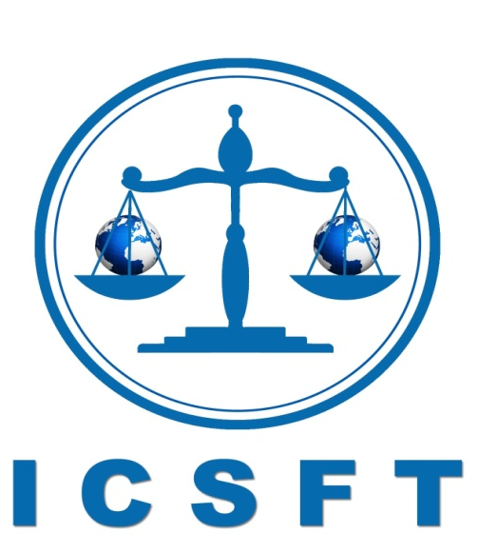
INTERNATIONAL COUNCIL SUPPORTING FAIR TRIAL AND HUMAN RIGHTS
Geneva Registration No. 2795

Petition to Release the blogger Hamad Al-Niqi who was sentenced to 10 years in prison for criticizing neighboring states leaderships
To His Highness the Emir of Kuwait: Sheikh Sabah Al-Ahmad Al - Jaber Al -Sabah
Hamad al-Naqi of Kuwait has been sentenced to ten years in prison for comments deemed to be critical of the state. The blogger made comments on his Twitter feed that questioned neighboring states’ policies, and was accused of negatively affecting political relations, among other charges. Recently, an appeal challenging the sentence was overturned, leaving al-Naqi to serve his full sentence.
The political blogger was charged with insulting neighboring leaders, provoking sectarian tensions and misusing a mobile device to disseminate questionable comments.
Al-Naqi is only one of many critics of the government that have been imprisoned for similar comments in Kuwait. Since a political crisis in summer of 2012, the Kuwaiti government has increasingly been abridging the rights of its citizens. Dozens of the country’s journalists, activists, and politicians have been arrested and imprisoned for “offending the leader,” after making statements contrary to the opinions of authorities.
Kuwait, as a member of the International Covenant on Civil and Political Rights and the Arab Charter on Human Rights, is required to uphold the rights of freedom of opinion and freedom of expression. Imprisonment for criticism of state institutions and officials is a clear breach of these rights, while an open discourse on current events and state politics is essential to improving human rights issues.
The ICSFT demands that Hamad al-Naqi be released immediately, and that all charges relating to his peaceful criticism be dropped.
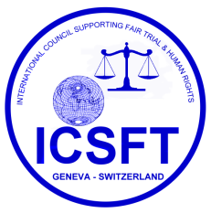
And Your Highness as the Emir of Kuwait possesses the right of pardon for verdicts, have had your Highness gesture dignified consistent with the values ​​and humanitarian principles and international conventions. By your Pardoning and the abolition of sentences passed on them, and therefore we look forward to equate this young man just like with other citizens of our dear country Kuwait.
Lawyer Dr.: Abdul Hameed Abbas Dashti
President of the International Council Supporting Fair Trial and Human Rights-Geneva
November 9, 2013

