Communique of the International Solidarity Meeting
“Supporting Democratic Transition and Human Rights in Bahrain."
Geneva: March 12, 2015
Since the 14th February 2011, the Kingdom of Bahrain has witnessed a peaceful popular uprising calling for a democratic transition of power, the establishment of good governance based on an effective constitution, an elected government and the separation and independence of powers.
The ongoing popular protests affirm its peaceful and legitimate demands, upon which observers from all spectra have seen; be they individuals, organizations, or governments. In contrast, the Bahraini authorities have resorted to repressive measures to crush the revolt. This has included the use of live ammunition, resulting in the deaths of more than 150 people by the Bahraini security forces, in addition to the hundreds wounded and thousands of political prisoners.
Bahraini authorities have declined to conduct a serious dialogue with the political opposition with the aim of formulating a set of ideas relating to building a democratic state based on a fair electoral law. Such a step is necessary for embodying a popular partnership and power sharing followed by an elected parliament that entertains the power of forming a national government.
Paradoxically, in the aftermath of four years of a popular revolt, the Bahraini authorities still refuse calls for dialogue; instead it continues a systematic repression by increasing the scale of arbitrary arrests and false trials that lack the minimum requirements for a fair trial.
Throughout the last four years, the number of political detainees in Bahrain has reached around 3,800, and this figure is a record in the world, given the relative size of the Bahraini population. In addition, the Bahraini authorities have removed the citizenships from tens of Bahraini figures, as a punitive measure against them for their participation in peaceful activities. This is despite its express violation of Article 15 of the Universal Declaration of Human Rights, which states: "Everyone has the right to have a nationality and it is not permissible to arbitrarily deprive any person of his nationality nor denying him the right to change his nationality".
The Bahraini authorities have unleashed a wrath of punitive measures against its people in response to the popular protest movement. Including, random firing against peaceful protesters, indiscriminate arbitrary arrests, raiding and tampering of homes, withdrawal of nationalities, travel bans, blockading specific areas, destroying mosques, as well as a general campaign of intimidation and threats. These all fall under the context of a collective punishment and may rise to crimes against humanity, described in Chapter VII of the Charter of the International Criminal Court.
In light of the periodic reports and annual and special cases of torture, arbitrary arrest and repression of activists, it is clear that the Bahraini Authorities are in flagrant violation of human rights charters, including the Universal Declaration of Human Rights and the International Covenants in spite of its approval by the government of Bahrain.
The Bahraini authorities continue to torture Human Rights defenders, to the extent of tracking everyone exercising their right to express their opinion in the current political and human rights situation. This includes social networking sites that have become subject to the control of the security forces and have lead to the detention on pre-designed charges of citizens of all age groups.
In a dangerous development connected with the status of human rights in Bahrain, the Gulf Cooperation Council (GCC) has begun to implement the Gulf security agreement, which was adopted on November 13 2012, despite no announcement of the approval of all the GCC countries and without following the procedural actions for its approval within the applicable constitutional frameworks.
As we express our deep concern over such an agreement and what it provides as justification for the suppression of all freedoms, we believe that one of its objectives is the elimination of the human rights movement in the Gulf Cooperation Council (GCC), and the prevention of Human Rights Defenders freedom of movement and communication between them. This agreement also allows the capture of anyone wanted persons and their handing over to the state that requested, and thus depriving human rights Defenders of their right to move between the GCC countries.
In light of the above, we draw the attention of member states of the UN Human Rights Council to the fact that human rights defenders in Bahrain and abroad are working in a police atmosphere threatened constantly by the Bahraini authorities to be arrested based on trumped-up charges. In Bahrain human rights work is interpreted as a serious crime that requires detention for long periods, while others are being prevented from traveling. In particular to countries conducting Human Rights activities, such as the Human Rights Council sessions in Geneva, to prevent informing delegations participating in the sessions about human rights violations recorded in these countries and violations registered.
At the same time the legislative authorities have renewed efforts to approve legislation to criminalize human rights work, let alone allow the establishment of human rights organizations. Just communicating with external organizations is considered a crime punishable by law, as well as appearing in the media to talk about the violations occurred against a person or group. Such actions fall within the charge of spreading false news and damaging the reputation of the State.
Recommendations
1. Appeal to the United Nations, represented by the Human Rights Council, to issue a resolution for the protection of Human Rights Defenders and to secure a deterrent legal cover for them during exercising their work.
2. Appeal to member states of the Human Rights Council to expedite the convening of a Special Session to discuss the human rights situation in Bahrain.
3. Wishing from His Excellency; the High Commissioner for Human Rights and the Special Rapporteurs to commit the government of Bahrain to apply the Declaration on the Right and Responsibility of Individuals, Groups and Organs of Society to promote and protect human rights and fundamental universally recognized freedoms within the national judiciary system.
4. Call on the international community to exert all forms of pressure on the government of the Kingdom of Bahrain:
A. To immediately release leaders of legal peaceful movements in particular, Sheikh Ali Salman, Secretary General of Al Wefaq National Islamic Society.
B. To activate all of the recommendations contained in the report submitted by the Independent Inquiry Committee under the supervision of Dr. Cherif Bassiouni, dated November 23rd 2011 and the recommendations made by the countries in the UPR (UPR13) in Geneva on May 21st 2012 during the review of the human rights situation in Bahrain.
C. To immediately stop the repression of peaceful protests and use of internationally prohibited weapons.
D. To stop the security and judicial targeting of political opponents and defenders of human rights within the Kingdom of Bahrain and abroad.
E. To activate tools of commitment of the International Covenant of Civil and Political Rights within the national judiciary.
F. To join the International Criminal Court in support of justice and against the culture of impunity.
G. To withdraw from the security agreement between the Gulf Cooperation Council (GCC) for its non-conformity with international conventions and the international humanitarian law.

Issued in Geneva on 12 March, 2015.

Coalition of The Human Rights International Organizations
 |  | EBOHR | 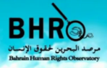 |  | 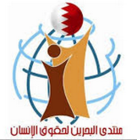
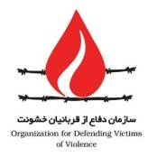 | 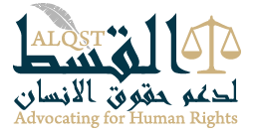 | 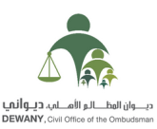 | 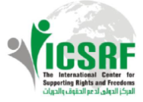 | 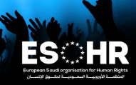 |  | ADHRB
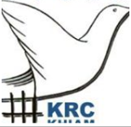 |  | 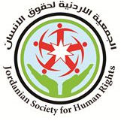 | E Arab Friendship Association | IPJ
 | Khiam Center for Habilitation of VOT | 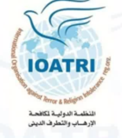 | Muslim Rights’ Defenders in Belgium | 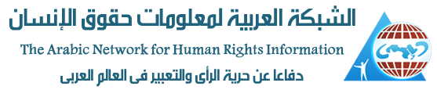 | Human Rights Defenders in Arab World

