Bahrain Ongoing Judicial Harassment
against BYSHR Co-Founders and Members for Their Cooperation with the UN System
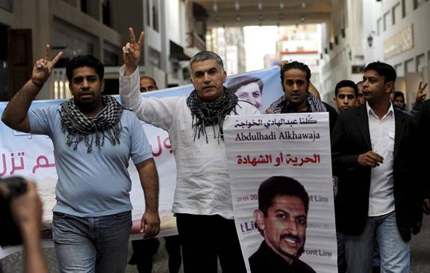

The Gulf Center for Human Rights (GCHR) , Bahrain Center for Human Rights (BCHR) and the International Council Supporting Fair Trial &Human Rights (ICSFT) express their serious concern over the ongoing campaign of judicial harassment against human rights defenders in Bahrain who cooperate with the UN system. In the recent days, Human rights defender Mohamed Al-Maskati was interrogated on charges related to freedom of expression, while another 2 defenders of his organization, the Bahrain Youth Society for Human Rights (BYSHR), are currently behind bars.
On 22 October 2013, human rights defender, co-founder and president of the BYSHR Mohamed Al-Maskati was summoned to Al-Khamis Police Station where he was interrogated on charges of “inciting hatred against the regime” in relation to a speech he made on 8 September 2013 in Jidhafs Town, where he talked about the concept of nonviolence and the importance of demanding rights through peaceful techniques as well as human rights as set in the Universal Declaration of Human Rights.
Defender Al-Maskati was released after he signed a pledge to appear before the Public Prosecution office upon request. His case may be transferred to court at any time.
Mohamed Al-Maskati is a renowned human rights defender, an advocate of non-violence and a trainer of Digital Security for human rights defenders. He has been actively cooperating with the UN Office of the High Commissioner for Human Rights (OHCHR) in recent years and has visited the Special Rapporteurs in August 2013. He also met several diplomatic missions in Geneva in coordination with many regional and international Human Rights organizations.
This summon comes at the end of a long list of judicial and extra-judicial harassment to human rights defender Al-Maskati. Since June 2013, he is going through a trial at the Lower Criminal Court, facing possible prison sentences on charges of “participation in illegal protests” in relation to his participation in a peaceful protest entitled “Self determination”. The next hearing will be on 9 December 2013.
Last year, on 16 October 2012, Al-Maskati was detained for about 24 hours and questioned at the Public Prosecution office on charges of “rioting and participating in an illegal gathering” few weeks after he delivered an oral intervention at the Human Rights Council (HRC) in Geneva, where he informed the (HRC) about the massive intimidation campaign against him. Although he was released after interrogation but the charges remained pending since then. After tweeting about his attendance at the 21st session of the UN Human Rights Council (HRC) in Geneva in September 2012, Al-Maskati received continuous threats via anonymous phone calls. He was threatened with death if “he damaged Bahrain’s reputation in Geneva”, and he was also a target of a smear campaign run by a pro-government newspapers following his return from Geneva.
Another two members of BYSHR are currently behind bars. Human rights defender and BYSHR co-founder Naji Fateel is detained since May 2013 and has been sentenced on 29 Sep 2013 to 15 years in prison after a show trial that fails to live up to fair trial standards. He was reportedly subjected to torture in detention. Human rights defender and member of BYSHR, Hussain Abdulnabi, is still detained while facing a trial since 6 Sep 2013. Some reliable reports confirmed that the security forces have a plan to target other members of the BYSHR.
The GCHR , BCHR and ICSFT believe that human rights defender Mohamed Al-Maskati has been targeted solely due to his co-operation with the UN system and in particular his role in documenting and reporting the continued human rights violations. In addition the GCHR and BCHR are concerned that the ongoing targeting of BYSHR members aims to hinder the work of the active and internationally renowned human rights organizations in Bahrain.
The GCHR , BCHR and ICSFT urge the UN, US administration as well as other governments that have influence in Bahrain including the UK government, the EU and the leading human rights organizations to put real pressure on the Government of Bahrain in order to:
1. Immediately stop the judicial harassment of human rights defenders and drop all charges against them and release the detained human rights defenders including Naji Fateel, Abdulhadi Al-Khawaja and Nabeel Rajab and stop the exploitation of the judiciary for political purposes;
2. Immediately stop the daily human rights violations as well as escalating attacks on human rights defenders;
3. Guarantee in all circumstances that all human rights defenders in Bahrain are able to carry out their legitimate human rights activities without fear of reprisals, and free of all restrictions including judicial harassment.
The GCHR , BCHR and ICSFT respectfully remind the government of Bahrain that the United Nations Declaration on the Right and Responsibility of Individuals, Groups and Organs of Society to Promote and Protect Universally Recognized Human Rights and Fundamental Freedoms, adopted by consensus by the UN General Assembly on 9 December 1998, recognizes the legitimacy of the activities of human rights defenders, their right to freedom of association and to carry out their activities without fear of reprisals. We would particularly draw your attention to Article 5 (b) which states that: “For the purpose of promoting and protecting human rights and fundamental freedoms, everyone has the right, individually and in association with others, at the national and international levels: (b) To form, join and participate in non-governmental organizations, associations or groups;” and to Article 12.2, which provides that “the State shall take all necessary measures to ensure the protection by the competent authorities of everyone, individually and in association with others, against any violence, threats, retaliation, de facto or de jure adverse discrimination, pressure or any other arbitrary action as a consequence of his or her legitimate exercise of the rights referred to in the present Declaration."
Dear Friends,
You can get our news at:
1. Web Sites: www.gc4hr.org & www.icsft.net
2.Facebook: http://www.facebook.com/pages/Gulf-Center-For-Human-Rights/273623332709903
3. Twitter: @GulfCentre4HR
4. E-mail: info@gc4hr.org & info@icsft.net
Thank you so much,
GCHR & ICSFT

